CCR Middle Markers
Time Trials 2024
(Promoted for and on behalf of Cycling Time Trials under their rules and Regulations)
Early spring 10-mile TT
28th April on the P881/10 (A3)
The Headquarters are at the:
Greatham Village Hall, Greatham, GU33 6EU, HQ open from 6.30am

Timekeepers: Maria Golden & Neil Panter
Start Line Stewards: Nolan Rogers CCR & Nick Gates CCR
Marshals & Crew: Emma Hanon, Heather Wiltshire, Lily Wiltshire, Oliva Sloan, Ross Kettle
Results: Will be available during the morning http://www.resultsheet.co.uk/

WORKING FRONT AND REAR LIGHTS AND HELMET ARE NOW MANDORTARY TO COMPETE IN CTT EVENTS
Parking – Please use the car park at the Village Hall and overspill field, be aware this is a residential area & many will (sensibly!) still be in their beds so please keep the noise levels down, no noisy turbo’s please. Be aware this is a residential, no parking in the vicinity of Greatham Church.
Event Secretary: Larry Wiltshire, 28 Laxton Leaze, Waterlooville, Hants – 07889170893
Race day contact
Greatham hall Larry or Heather Wiltshire 07889170893 email: Larry_wiltshire@hotmail.com
The preferred and safe route to the start: To ride to the Start: Turn right upon leaving the HQ and allow at least eight minutes getting to the Start. There is no need to go back & forth to the start as we do not move it once the event has started.
The preferred and safe route back to the HQ; After the finish proceed to Ham Barn roundabout and take the third exit, proceed along the B3006 to return to HQ and car park.
Procedure During the Event:
You Must Use a rear and front light & it must be switched on
If caught, ease back; do not take pace on the wheel of the rider who caught you If passing a rider please make sure the effort is enough to pass completely
Look where you are going, keep your head up & please don't hog the carriageway, keep to the inside lane at all times.

There will be tea and coffee after the ride and cakes that are being made by our CCR member, any donations for the cake will go to the CCR charity of choice which is St Wilfreds Hospice

Prizes | 1st | 2nd | 3rd
Middle Marker Women’s Event | £20 | £15 | £5
Middle Marker Men’s Event | £20 | £15 | £5
Middle Marker Road Bike Event | £20 | £15 | £5
Scratch Women’s Event | £20 | £15
Scratch Open Men’s Event | £20 | £15 | £5

Prizes will be presented after the event, please stay & appauld the victors of the day. Prizes not collected will be deemed as donations to St-Wilfreds hospice the CCR charity of choice.

Course Details 10 Mile TT ~ Greatham – West Liss / Liphook A3 ~ P881/10 mile
Start on the B3006 off the A3 Liss/Selborne turning 190 yards from the Ham Barn roundabout at a point 17 yards west of centre of three concrete manhole covers on the tarmac footpath.
Proceed to the roundabout and take the first exit on to the A3 signposted Guildford London. Proceed north passing turnings for the (1) A325 (Farnham) (2) Griggs Green, at the third turning (5.2 miles) take the left turn signposted Haslemere-Liphook, and continue over the flyover taking the left turn onto the slip road to rejoin the A3 in a southerly direction (signposted Petersfield –Portsmouth).
Retrace along A3 towards the Ham Barn Roundabout to finish at the third marker on the lay- by approximately 600 yards north of Ham Barn roundabout (10 miles).
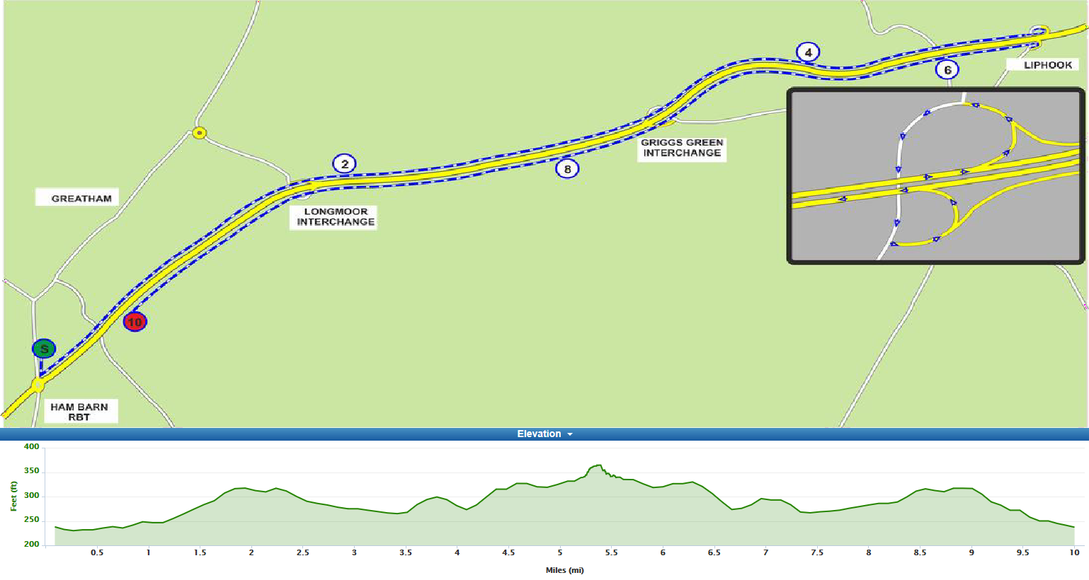
Course record: Kate Allan 00:20:11 Christopher Fennell 00:17:33
Middle Marker Event
BIB No. | NAME | CLUB | MACHINE TYPE | CAT | EVENT | START TIME
1 | Darren Anderson | Fareham Wheelers CC | TT Bike | Vet-M | MID MARK | 07:31
2 | James Roberson | Bristol South Cycling Club | TT Bike | Vet-M | MID MARK | 07:32
3 | Danielle Forshaw | Velo Club Venta | Road Bike | Sen-F | MID MARK | 07:33
4 | Alan Davies | Hampshire Road Club | Road Bike | Vet-M | MID MARK | 07:34
5 | Christopher Redmond | Petersfield Triathlon Club | TT Bike | Vet-M | MID MARK | 07:35
6 | Henry Austin | Poole Wheelers Cycling Club | TT Bike | Sen-M | MID MARK | 07:36
7 | Ben George | New Forest CC | TT Bike | Sen-M | MID MARK | 07:37
8 | Chris McGuire | Hampshire Road Club | TT Bike | Vet-M | MID MARK | 07:38
9 | Martin Whitty | ...a3crg | TT Bike | Vet-M | MID MARK | 07:39
10 | Geoff Newman | Farnham RC | TT Bike | Vet-M | MID MARK | 07:40
11 | Graham White | Fareham Wheelers CC | TT Bike | Vet-M | MID MARK | 07:41
12 | Sheena Keates | GS Mossa | TT Bike | Vet-F | MID MARK | 07:42
13 | Rachael Lamont | Portsmouth North End CC | TT Bike | Vet-F | MID MARK | 07:43
14 | Alex Booker | Farnborough & Camberley CC | TT Bike | Vet-M | MID MARK | 07:44
15 | Gary Tuskin | Poole Wheelers Cycling Club | TT Bike | Vet-M | MID MARK | 07:45
16 | Duncan Folkes | Kingston Phoenix RC | TT Bike | Vet-M | MID MARK | 07:46
17 | Christopher Rosam | Epsom CC | TT Bike | Vet-M | MID MARK | 07:47
18 | Simon Craig-McFeely | ...a3crg | TT Bike | Vet-M | MID MARK | 07:48
19 | Harry Darrah | Chichester City Riders | Road Bike | Sen-M | MID MARK | 07:49
20 | David Welling | Farnham RC | TT Bike | Vet-M | MID MARK | 07:50
21 | David Knight | Portsmouth North End CC | TT Bike | Vet-M | MID MARK | 07:51
22 | Sam Hadnett | Chichester City Riders | Road Bike | Sen-M | MID MARK | 07:52
23 | Andrew Gibson | Gravesend CC | TT Bike | Vet-M | MID MARK | 07:53
24 | Steve Skinner | Southdown Velo | TT Bike | Vet-M | MID MARK | 07:54
25 | Rob Luff | GS Stella | TT Bike | Vet-M | MID MARK | 07:55
26 | Stewart Harrison | Team Bottrill | TT Bike | Vet-M | MID MARK | 07:56
27 | Mike Boyce | ...a3crg | TT Bike | Vet-M | MID MARK | 07:57
28 | Gary Chiverton | Bournemouth Jubilee Whs | TT Bike | Vet-M | MID MARK | 07:58
29 | Cliff Voller | VTTA West Group | TT Bike | Vet-M | MID MARK | 07:59
30 | Jerry Bromyard | ...a3crg | TT Bike | Vet-M | MID MARK | 08:00
31 | Richard Keevil | GS Stella | TT Bike | Vet-M | MID MARK | 08:01
32 | Stuart Thompson | Velo Club St Raphael | TT Bike | Vet-M | MID MARK | 08:02
33 | Richard Llewellyn | Imperial Racing Team | TT Bike | Vet-M | MID MARK | 08:03
34 | Adam Coppard | Chichester City Riders | Road Bike | Sen-M | MID MARK | 08:04
35 | Matthew Butler | Charlotteville Cycling Club | TT Bike | Sen-M | MID MARK | 08:05
36 | Peter Phipps | ...a3crg | TT Bike | Vet-M | MID MARK | 08:06
37 | Martin Beale | Velo Club St Raphael | TT Bike | Vet-M | MID MARK | 08:07
38 | Demetrius Onoufriou | Farnham RC | TT Bike | Vet-M | MID MARK | 08:08
39 | Peter Barlow | Royal Navy & Royal Marines CA | TT Bike | Sen-M | MID MARK | 08:09
40 | Laurence Brown | Chichester City Riders | TT Bike | Sen-M | MID MARK | 08:10
41 | Tom Quinlan | FTP Race Team | TT Bike | Sen-M | MID MARK | 08:11
42 | Stuart Peckham | Velo Club St Raphael | TT Bike | Vet-M | MID MARK | 08:12
43 | Sarah Matthews | ...a3crg | TT Bike | Vet-F | MID MARK | 08:13
44 | John McDonald | trainSharp | TT Bike | Vet-M | MID MARK | 08:14
45 | Andrew Phipps | Royal Navy & Royal Marines CA | TT Bike | Vet-M | MID MARK | 08:15

BIB No. | NAME | CLUB | MACHINE TYPE | CAT | EVENT | START TIME
46 | Simon Berogna | Velo Club St Raphael | TT Bike | Vet-M | SCRATCH | 08:16
47 | Larry Wiltshire | Chichester City Riders | TT Bike | Vet-M | SCRATCH | 08:17
48 | Malcolm Cox | Velo Club St Raphael | TT Bike | Vet-M | SCRATCH | 08:18
49 | Ben Schooling | Chichester City Riders | TT Bike | Vet-M | SCRATCH | 08:19
50 | Lisa Davis | DRAG2ZERO | TT Bike | Vet-F | SCRATCH | 08:20
51 | Graham Harman | Sotonia CC | TT Bike | Vet-M | SCRATCH | 08:21
52 | Kim Barfoot-Brace | Team Bottrill | TT Bike | Vet-F | SCRATCH | 08:22
53 | James Ayton | Portsmouth North End CC | TT Bike | Vet-M | SCRATCH | 08:23
54 | William Sawyer | Velo Club St Raphael | TT Bike | Vet-M | SCRATCH | 08:24
55 | Daniel Legg | North Hampshire RC | TT Bike | Vet-M | SCRATCH | 08:25
56 | James Smee | Chichester City Riders | TT Bike | Vet-M | SCRATCH | 08:26
57 | Ben Elliott | Paceline RT | TT Bike | Vet-M | SCRATCH | 08:27
58 | Chris Newman | Farnham RC | TT Bike | Sen-M | SCRATCH | 08:28
59 | Peter Allan | Team Velo Sportif | TT Bike | Vet-M | SCRATCH | 08:29
60 | Adrian Ford | Brighton Mitre CC | TT Bike | Sen-M | SCRATCH | 08:30
61 | Peter Main | 34 Nomads CC | TT Bike | Vet-M | SCRATCH | 08:31
62 | Peter Younghusband | Petersfield Triathlon Club | TT Bike | Vet-M | SCRATCH | 08:32
63 | Andrew Rivett | Velo Club St Raphael | TT Bike | Vet-M | SCRATCH | 08:33
64 | Aaron Borrill | Farnborough & Camberley CC | TT Bike | Vet-M | SCRATCH | 08:34
65 | Keith Lea | Paceline RT | TT Bike | Vet-M | SCRATCH | 08:35
66 | Brett Davis | DRAG2ZERO | TT Bike | Vet-M | SCRATCH | 08:36
67 | Stuart Hourigan | VeloRefined Rule 5 | TT Bike | Vet-M | SCRATCH | 08:37
68 | Stuart Bettis | One Resourcing RT | TT Bike | Sen-M | SCRATCH | 08:38
69 | Neil Mackley | ...a3crg | TT Bike | Vet-M | SCRATCH | 08:39
Scratch Event

